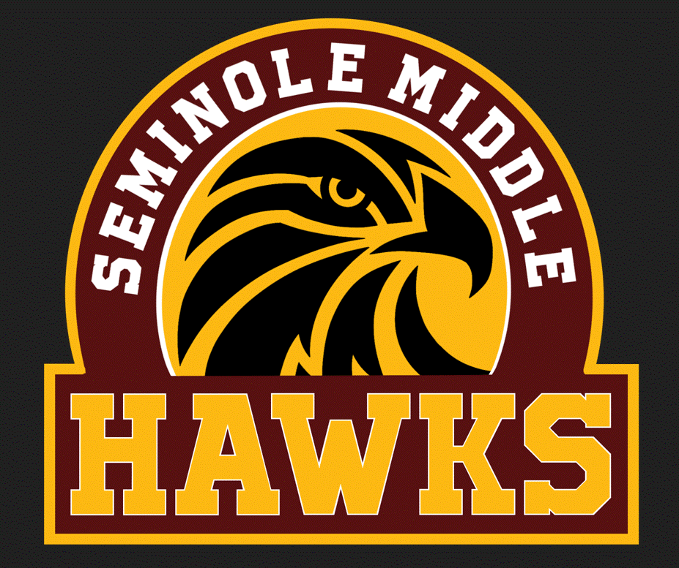
Seminole Middle School
Tue, Wed & Fri Bell Schedule 2025-2026

1st Lunch |  | 2nd Lunch
1 | 9:40 – 10:30 (50) | 1 | 9:40 – 10:30
2 | 10:33 – 11:21(48) | 2 | 10:33 – 11:21
L | 11:24 – 11:54 | 3 | 11:24 – 12:12 (48)
3 | 11:57 – 12:45 (48) | L | 12:15 – 12:45
4 | 12:48 – 1:36 (48) | 4 | 12:48 – 1:36
5 | 1:39 – 2:27 (48) | 5 | 1:39 – 2:27
6 | 2:30 – 3:18 (48) | 6 | 2:30 – 3:18
7 | 3:21 – 4:10 (49) | 7 | 3:21 – 4:10

Mon and Thurs Bell Schedule 2025-2026

1st Lunch |  | 2nd Lunch
TL | 9:40 – 10:05 (25) | TL | 9:40 – 10:05
1 | 10:08 – 10:53 (45) | 1 | 10:08– 10:53
2 | 10:56 – 11:41 (45) | 2 | 10:56– 11:41
L | 11:43 – 12:13 | 3 | 11:43 – 12:28
3 | 12:14 – 12:59 (45) | L | 12:29 – 12:59
4 | 1:01 – 1:46 (45) | 4 | 1:01 – 1:46
5 | 1:49 – 2:34 (45) | 5 | 1:49 – 2:34
6 | 2:37 – 3:22 (45) | 6 | 2:37 – 3:22
7 | 3:25 – 4:10 (45) | 7 | 3:25– 4:10

